I find setting up the testbench waves to be a pain, especially when you are making a lot of
mistakes and need to rerun your simulation multiple times; each time setting up the waveforms. To simplify the process of setting up the waveforms, you can write a script files that performs the waveform setup and then call the script file inside Questa. The script file is called a “do” file. They are very easy to make and will save you time. If a do file is provided
to you, you will most likely need to edit it because your signal names may be different.
In the discussion below I have used two placeholders: <labName> is the name of your testbench module. <projectDirectory> is the system path to your Verilog files corresponding to your project.
- If provided, download <labName>_tbWaveSetup.do into the: <projectDirectory>\simulation\questa directory. If this folder does not exit, then you need to run “Start Analysis and Elaboration” at least once. You will know you are in <projectDirectory> when you see the project QPF file.
- If a do file is not created, you can use the template provided in Listing 1 as a starting point to make one for yourself. Make sure to put the do file in the:
<projectDirectory>\simulation\questa directory
- Open <labName>_tbWaveSetup.do file using a text editor. The syntax is pretty straight forward and corresponds to the text displayed in the Questa console window when you add or modify waveforms.
- From Quartus, you need to:
- Make sure that your testbench is the top-level. Do this in the Project Navigator, select File view and then right click on the file testbench and select “Set As Top Level Entity”.
- Launch the simulation. Do this by selecting Tools – Run Simulation Tool – RTL Simulation.
- This will launch Questa for your testbench.
- From Questa, you need to:
- Maximize the Questa window – this makes it easier to see all the sub windows.
- In the library sub window, open the work library.
- Right click on your testbench and select Simulate.
- Run the simulation using Simulate – Run – Run 100. If you skip this step you will get an error as follows:
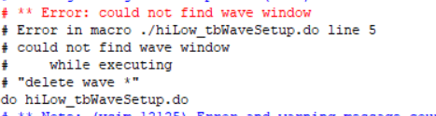

- In the console area of Questa (shown in the image below) type:
VSIM 3> do <projectName>_tbWaveSetup.do
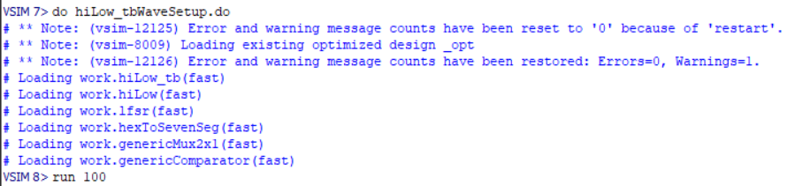

- You can type “run <time>” in this area (as shown) to simulate some amount of time. I found this VERY handy when debugging my Verilog code.
- Also note that the console has tab completion. This allows you to type the first few characters of a command/filename and press Tab to fill in the rest of the command/filename. If there is more than one choice, the command/filename will be completed up to the ambiguity.
Example do file for hiLow Module
- Run the test bench for the hiLow module provided on Canvas. Produce a timing diagram with the following characteristics. Zoom to fill the available horizontal space with the waveform. Color inputs green and outputs red. Order the traces from top to bottom as:
signal | radix | color trace
t_seedSwitch | unsigned | green
t_guessSwitch | unsigned | green
t_playSwitch | unsigned | green
t_randBut | default | green
t_hiLowBut | default | green
LFSR | unsigned | yellow
t_randNum | hex | red
t_randDisp | hex | red
t_hiLowSeg | hex | red
t_greenLEDs | default | red

- The do file for this testbench is shown in Listing 1. From top to bottom the sections are as follows.
  - Any line that starts with a “#” is a comment.
  - The restart command resets the simulation. I included this because I sometimes like to rerun the same simulation multiple times. This isn’t particularly useful for combinational logic circuits.
  - The delete wave command removes any waveforms that may have been added previously. Again, I included this because I sometimes like to rerun the same simulation multiple times.
  - The add wave command puts a signal into the waveform viewing area. There are two parameters included which you will find helpful.
    - Radix changes what base the waveform value is displayed.
    - Color changes the color that the waveform is displayed.
- Once you have created the do file, you call it by running it from the console area using the do command discussed previously.
- You can advance the simulation time using the run command discussed previously.
Listing 1: do file for hiLow_tb.
########################################################################################
#File: hiLow_tb Wave Setup.do
########################################################################################
restart −f
delete wave ∗
add wave -position end -radix unsigned -color green sim:/hiLow_tb/t_seedSwitch
add wave -position end -radix unsigned -color green sim:/hiLow_tb/t_guessSwitch
add wave -position end -radix unsigned -color green sim:/hiLow_tb/t_playSwitch
add wave -position end -color green sim:/hiLow_tb/t_randBut
add wave -position end -color green sim:/hiLow_tb/t_hiLowBut
add wave -position end -radix unsigned -color yellow sim:/hiLow_tb/uut/randNum
add wave -position end -radix hex -color red sim:/hiLow_tb/t_randDisp
add wave -position end -radix hex -color red sim:/hiLow_tb/t_hiLowSeg
add wave -position end -color red sim:/hiLow_tb/t_greenLEDs

Questa SIM commands
Questa macros (also called DO files) are scripts that contain Questa and, optionally, Tcl commands. You run the commands by typing them in the console window at the bottom of the Questa window. You can find more commands in the Questa simulation User guide.pdf posted under the Lab module in canvas.

